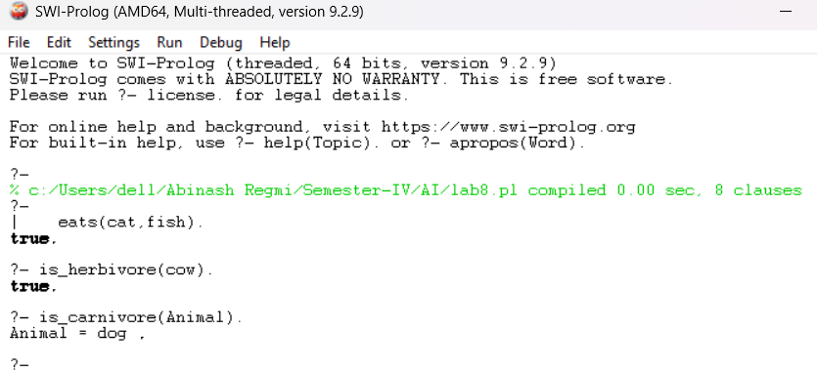**OUTPUT:**



**OUTPUT:**

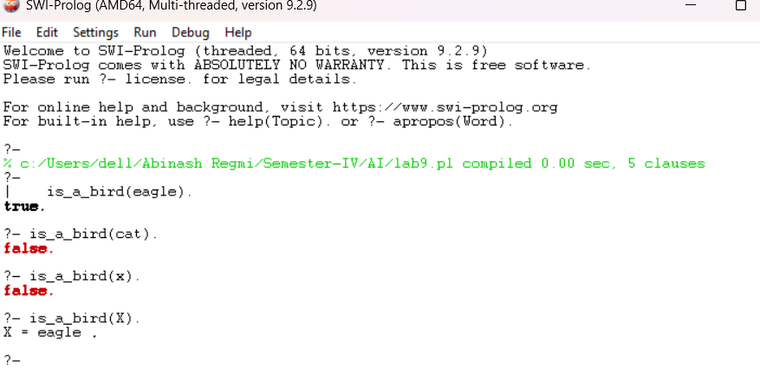

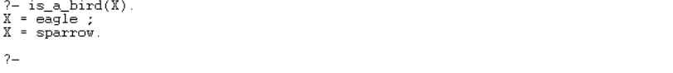

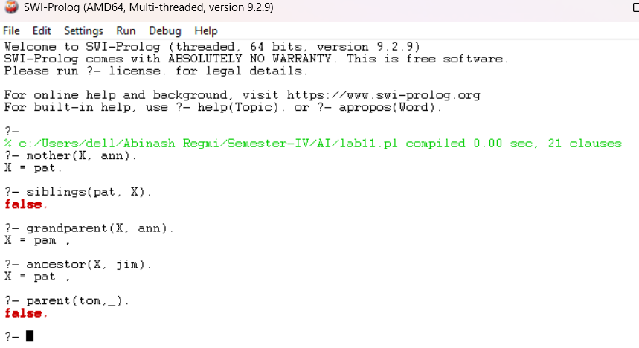**OUTPUT:**

**OUTPUT:**



**SOURCE CODE:**

import numpy as np

import pandas as pd

import matplotlib.pyplot as plt

df = pd.read_csv('housing_prices.csv')

X = df[['area_sqft', 'num_rooms']].values

y = df['price'].values

X = (X - X.mean(axis=0)) / X.std(axis=0)

y_min, y_max = y.min(), y.max()

y_norm = (y - y_min) / (y_max - y_min)

def sigmoid(z):

return 1 / (1 + np.exp(-z))

weights = np.random.randn(2)

bias = 0

lr = 0.1

epochs = 1000

for epoch in range(epochs):

z = np.dot(X, weights) + bias

y_pred = sigmoid(z)

mse_loss = np.mean((y_pred - y_norm) ** 2)

if((epoch+1)%50==0):

print(f"Epoch:{epoch+1}, loss= {mse_loss}")

dE_dy = (y_pred - y_norm)

dy_dz = sigmoid(z) * (1 - sigmoid(z))

dz_dw = X

dz_db = 1

grad_w = np.dot(dz_dw.T, dE_dy * dy_dz) / len(X)

grad_b = np.sum(dE_dy * dy_dz * dz_db) / len(X)

weights -= lr * grad_w

bias -= lr * grad_b

weights

bias

test_area = 2135

test_rooms = 4

test_X = np.array([test_area, test_rooms])

test_X_norm = (test_X - df[['area_sqft', 'num_rooms']].mean().values) / df[['area_sqft', 'num_rooms']].std().values

z_test = np.dot(test_X_norm, weights) + bias

pred_norm = sigmoid(z_test)

pred_price = pred_norm * (y_max - y_min) + y_min

print(f"Predicted Price for area={test_area} sq ft and rooms={test_rooms}: {pred_price:.2f}")

import pandas as pd

import numpy as np

import torch

import torch.nn as nn

import torch.optim as optim

import matplotlib.pyplot as plt

df = pd.read_csv('housing_prices.csv')

X = df[['area_sqft', 'num_rooms']].values

y = df['price'].values

X_mean = X.mean(axis=0)

X_std = X.std(axis=0)

X_norm = (X - X_mean) / X_std

y_min, y_max = y.min(), y.max()

y_norm = (y - y_min) / (y_max - y_min)

X_tensor = torch.tensor(X_norm, dtype=torch.float32)

y_tensor = torch.tensor(y_norm.reshape(-1, 1), dtype=torch.float32)

class SingleLayerModel(nn.Module):

def __init__(self):

super(SingleLayerModel, self).__init__()

self.linear = nn.Linear(2, 1)

def forward(self, x):

z = self.linear(x)

return torch.sigmoid(z)

model = SingleLayerModel()

criterion = nn.MSELoss()

optimizer = optim.SGD(model.parameters(), lr=0.01)

epochs = 10000

for epoch in range(epochs):

y_pred = model(X_tensor)

loss = criterion(y_pred, y_tensor)

print(f"Epoch: {epoch+1}, loss:{loss}")

optimizer.zero_grad()

loss.backward()

optimizer.step()

with torch.no_grad():

final_preds_torch = model(X_tensor).numpy().flatten()

final_preds_denorm = final_preds_torch * (y_max - y_min) + y_min

plt.scatter(df['area_sqft'], df['price'], label="Data points")

plt.plot(df['area_sqft'], final_preds_denorm, color='red', label="Best Fit Line (PyTorch)")

plt.xlabel("Area (sq ft)")

plt.ylabel("Price")

plt.title("Area vs Price (Custom nn.Module + SGD)")

plt.legend()

plt.show()

for name, param in model.named_parameters():

print(f"{name}: {param.data.numpy()}")

print("Final MSE Loss:", loss.item())

test_input = np.array([[2135, 4]], dtype=np.float32)

test_input_norm = (test_input - X_mean) / X_std

test_tensor = torch.tensor(test_input_norm, dtype=torch.float32)

with torch.no_grad():

pred_norm = model(test_tensor).item()

pred_price = pred_norm * (y_max - y_min) + y_min

print(f"Predicted Price for area=2135 sq ft and rooms=4: {pred_price:.2f}")

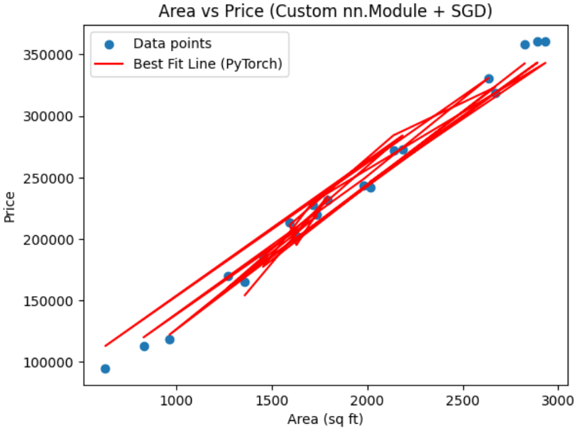**OUTPUT (**lr=0.1**):**

**OUTPUT (lr=0.001):**

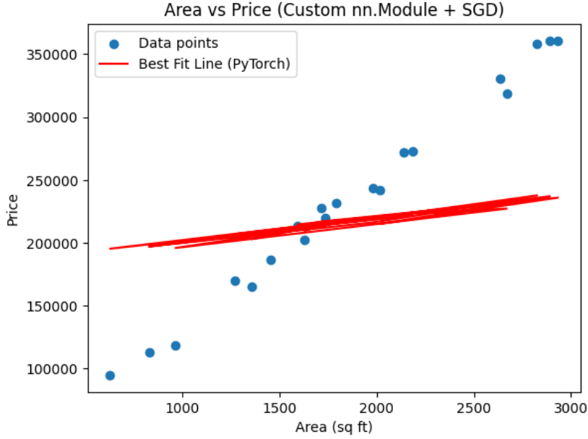

**OUTPUT (lr=0.4):**

